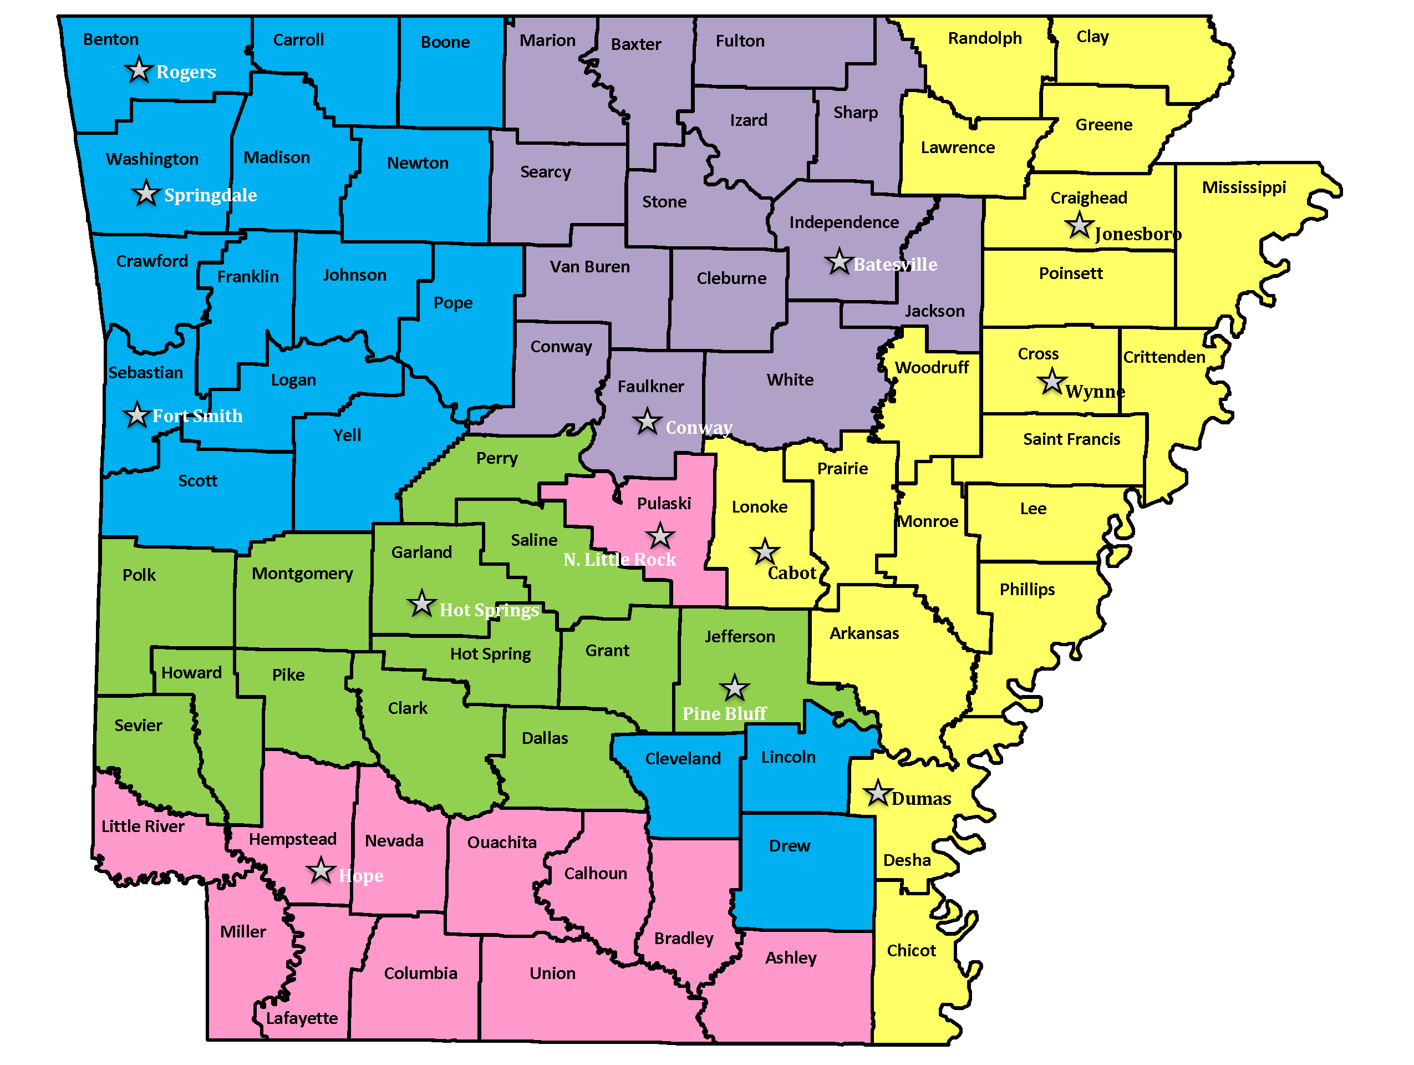

Agency | Office County | Contact | Email | Phone | Website
Child Care Aware of  Northwest Arkansas and River Valley | Washington | Carolene Thornton  Director | cthornton@nwachildcare.org | 1-479-751-3463  Fax: 1-479-751-1110 | nwachildcare.org
 | Benton | Michelle Wynn | mwynn@nwachildcare.org | 1-479-751-3463  Fax: 1-479-751-1110
 | Sebastian | Erica Holland | eholland@nwachildcare.org | 1-479-222-6930  Fax: 1-479-222-6930
Child Care Aware of  Northcentral Arkansas | Independence | Debbie Webb  Director | debbie@wrpdd.org | 1-800-737-2237  Fax: 1-870-793-4035 | CCANA.org
 | Faulkner | Carol Crockett | carolcrockett5@gmail.com | 1-501-327-6677  Fax: 1-501-327-6677
Child Care Aware of Northeast Arkansas and Lonoke County | Craighead | Jo Battle  Director | jbattle@astate.edu | 1-888-429-1585  Fax: 1-870-972-3556 | chs.astate.edu
 | Cross | Valerie Cathey | vcathey@astate.edu | 1-870-208-8832  Fax: 1-870-208-8833
 | Lonoke | Meghan Anderson | manderson@astate.edu | 1-501-941-2880  Fax: 1-501-941-3551
Child Care Aware of Central and Southwest Arkansas | Pulaski | Terrie Baker  Director | terrie.baker@childcareawarecswa.org | 1-501-374-0330  Fax: 1-501-374-2414 | childcareawarecswa.org
 | Hempstead | Dianna Stratton | dianna.stratton@childcareawarecswa.org | 1-870-474-5191  Fax: 1-501-374-2414
Child Care Aware of  West Central Arkansas | Garland | Terri Helms  Director | thelms1@np.edu | 1-501-760-6588  Fax: 1-501-760-4399 | np.edu/childcare-aware

