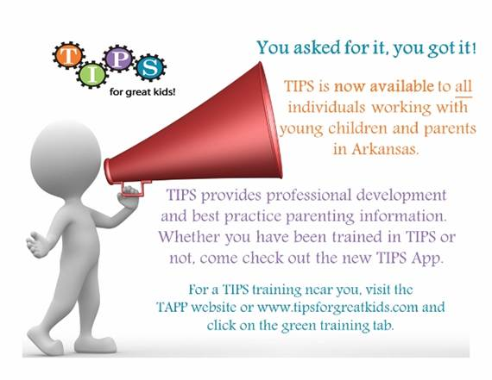

**TIPS – Teaching Important Parenting Skills Basic Training**

**Tuesday, January 31 – 9:00 am – 12:00 pm**

**Tuesday, March 7 – 6:00 pm – 9:00 pm**

TIPS is an exciting way of educating teachers and parents on a wide variety of early childhood topics.  TIPS trained staff will have access to best practice parenting information immediately at their fingertips via the web, Android, and Apple platforms.  This training emphasizes teacher-parent partnerships in the context of promoting positive child outcomes.  Participants will learn practical strategies for assessing parent’s needs and interests, as well as how to deliver parenting information through brief conversations with parents.

The TIPS for Great Kids app is a web-based application; therefore, those with access to computers, tablets, and/or smartphones in the classroom will greatly benefit from this training.

Bring your laptop, tablet, or smartphone for immediate access to the TIPS app.

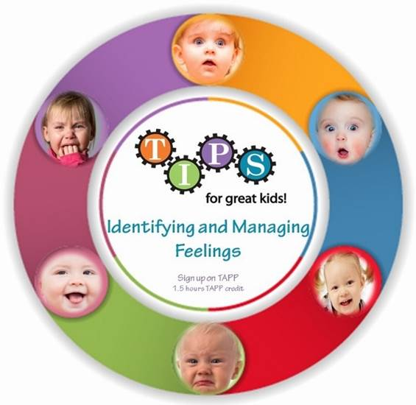

**TIPS – Identifying and Managing Feelings in Young Children**

**Tuesday, January 31 – 1:30 pm – 3:00 pm**

This training is for those that wish to create a more peaceful classroom learning environment.  It emphasizes the importance of children learning to identify and manage their feelings.  Participants will gain practical classroom strategies to teach these skills, as well as ways to partner with parents.